ACME Inc Network Vulnerability Test

Testing Network Security

Constantinos Sakkas (2200984)

BSc Cybersecurity Year 3

CMP314: Computer Networking 2

2024-25

Note that Information contained in this document is for educational purposes.

1. Table of Contents
2. Table of Contents 2
3. Addressing Table – Known Devises Found 3
4. Subnet Table 3-4
5. 1 - Introduction 4
6. 1.1 - Background 4
7. 1.2 - Aim of the Test 4
8. 1.3 - Tools used for the networking test 4-5
9. 2- Network Diagram 6
10. 3-Network Mapping 7
11. 3.1 - Mapping 7
12. 3.2 – Using Nmap 7-8
13. 3.3 – Scanning the Networks 8-9
14. 3.4- Accessing Router 1 9-10
15. 3.4.1 Investigating the Ip addresses from figure 6 10
16. 3.4.1 -PC – 192.168.0.210/27 11-15
17. 3.5 – Router 2 – 192.168.0.226/30 15
18. 3.5.1 – PC1 – 192.168.0.34/27 16-19
19. 3.5.2 – Exploiting PC2 – 13.13.13.13/24 20-21
20. 4 – Router 3 – 192.168.0.230/30 21-22
21. 4.1 – PC3 – 192.168.0.130/27 22-24
22. 4.2 – Web Server – 192.168.0.242/30 24-25
23. 4.2.1 – Using Dirp against the web server 26
24. 4.2.2 – Using Metasploit (Shellshock) 26-28
25. 4.3 Firewall 27-28
26. 5 Security weaknesses 28
27. 5.1 – Vyos Routers 1,2,3 28-29
28. 5.2 Basic PC Passwords30
29. 5.3 NFS Sharing30
30. 5.4 Web Server 30
31. 5.5 Firewall30
32. 5.6 Network Design Critical Evaluation 31
33. 5.7 Conclusion 31
34. References 32
35. Appendixes 33
36. Appendix A-Subnet calculations 33-37

Addressing Table – Known Devises Found:

|  |  |  |  |
| --- | --- | --- | --- |
| Devise | Interface | Subnet Mask | Default Gateway |
| Kali | Eth 0 | 255.255.255.224 | 192.168.0.193 |
| Router 1 | eth1 | 255.255.255.252 | 192.168.0.226 |
| eth2 | 255.255.255.0 | 172.16.221.16 |
| eth3 | 255.255.255.224 | 192.168.0.193 |
| Router 2 | eth1 | 255.255.255.224 | 192.168.0.33 |
| eth2 | 255.255.255.252 | 192.168.0.229 |
| eth3 | 255.255.255.252 | 192.168.0.226 |
| Router 3 | eth1 | 255.255.255.224 | 192.168.0.130 |
| eth2 | 255.255.255.252 | 192.168.0.233 |
| eth3 | 255.255.255.252 | 192.168.0.229 |
| Router 4 | Uknown | 255.255.255.252 | 192.168.0.97 |
| Uknown | 255.255.255.224 | 192.168.0.241 |
| Web server | 192.168.0.24 | 255.255.255.224 | 192.168.0.241 |
| Firewall | WAN | 255.255.255.224 | 192.168.0.235 |
| LAN | 255.255.255.224 | Uknown |
| DMZ | 255.255.255.252 | 192.168.0.243 |

Subnet Table:

The ACME network consists of 10 subnets that were found , all ip calculations can be found in Appendix A.

|  |  |  |  |
| --- | --- | --- | --- |
| Default Gateway | Subnet Mask | Range of ip | Broadcast Address |
| 192.168.0.192/27 | 255.255.255.224 | 192.168.0.192-  192.168.0.222 | 192.168.0.223 |
| 192.168.0.224/30 | 255.255.255.252 | 192.168.0.225-  192.168.0.226 | 192.168.0.227 |
| 192.168.0.32/27 | 255.255.255.224 | 192.168.0.33-  192.168.0.62 | 192.168.0.63 |
| 192.168.0.128/27 | 255.255.255.224 | 192.168.0.129-  192.168.0.158 | 192.168.0.159 |
| 192.168.0.228/30 | 255.255.255.252 | 192.168.0.229-  192.168.0.230 | 192.168.0.231 |
| 192.168.0.232/30 | 255.255.255.252 | 192.168.0.233-  192.168.0.234 | 192.168.0.235 |
| 192.168.0.240/30 | 255.255.255.252 | 192.168.0.241-  192.168.0.242 | 192.168.0.243 |
| 192.168.0.96/27 | 255.255.255.224 | 192.168.0.97-  192.168.0.126 | 192.168.0.127 |
| 13.13.13.0/34 | 255.255.255.0 | 13.13.13.1-13.13.13.254 | 13.13.13.255 |
| 172.16.227.0/24 | 255.255.255.0 | 172.16.221.1- 172.16.221.254 | 172.16.221.255 |

1 Introduction

1.1 Background:

Recently ACME Inc may have recently parted ways with their network management and acrimonious circumstances. When the company attempted to review the documents for their network, they had found out that there was no evidence on the killing documentation having been produced Still. The lack of documentation had raised concerns with the senior manager, and they were worried about the state of the network's overall security.

Due to these concerns, they have tasked him to evaluate their security of their network and have provided a computer for me to use per load with Kali Linux ACMA here have stated that they only want me to use tools are presented on the preload Kelly Linux machine as are concerned with the fact of using unproven tools on their network. Using the machine they have provided the credentials for it as well which are **root** for username and **toor** for password.

1.2 Aim of the Test:

The aim of this test is to help ACME Inc understand what security vulnerabilities are present in their company network and provide as much possible data to them of what a malicious attacker could do if they gained access to their network as well to map out their network and find more vulnerabilities throughout the tests conducted.

In addition, create more awareness of what the outcome can be if a network is not configured correctly through this report and as well for easy replication for an ACME worker for future use.

**1.3 Tools used for the networking test:**

* Firefox – access web server and firewall.
* Nmap – scanning ip address and ports.
* Metasploit – exploit a devise.
* Draw.io – draw network topology.
* Dirb – scan open directories.

1.4 - Network Diagram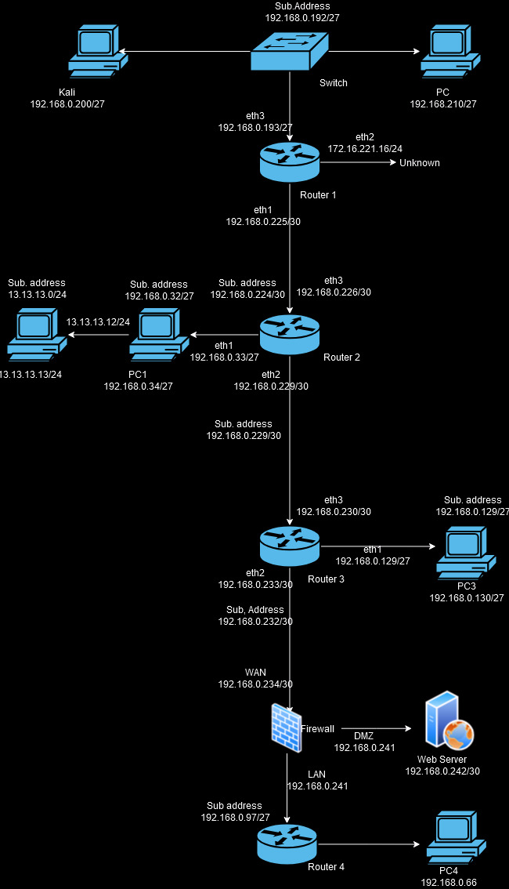

3 Network Mapping:

3.1- Mapping:

Using the kali terminal shown in figure 1 and typing ifconfig we router 1 and the loopback which is the local host Kali Linux – 192.168.0.200 and Subnet 255.255.255.224, broadcast address – 192.168.0.223.

**Ifconfig**

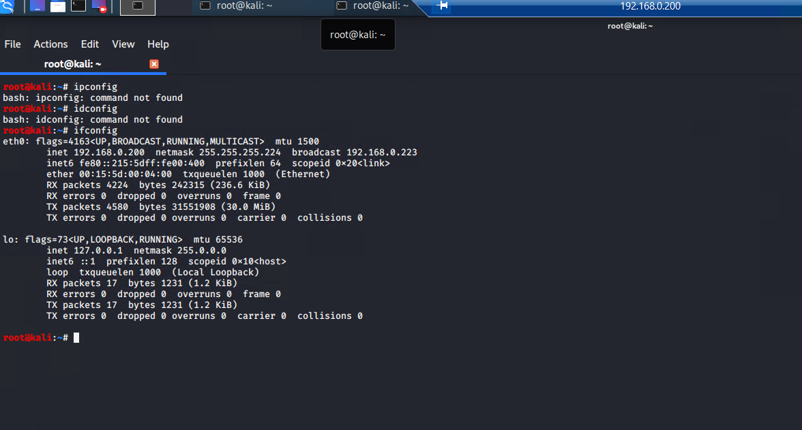

Figure 1

3.2 Using Nmap:

As we have a subnet 224 and shown in the following figure2 it would be useful to scan for the rest of the networks using /27 to discover more devises within the network.

Figure 2 below shows additional networks within the network 193 being Router 1 which will be the access point to map out the rest of the network and 210 which at this stage is unknown. As well in the last line of the output shows 32 ip addresses and the logic using 27/ is only 27 out of 32 bits are used for the IP address when converted to binary 11111111.11111111.11111111.11100000 which when the ones are counted are 27 in total.

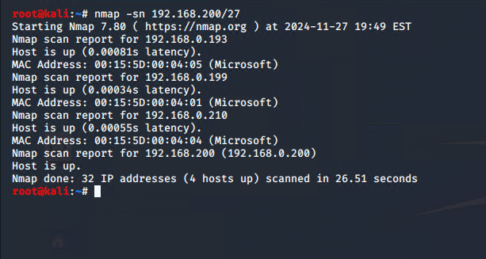

Figure 2

3.3-Scanning the Networks

Nmap -sV 192.168.0.192/27

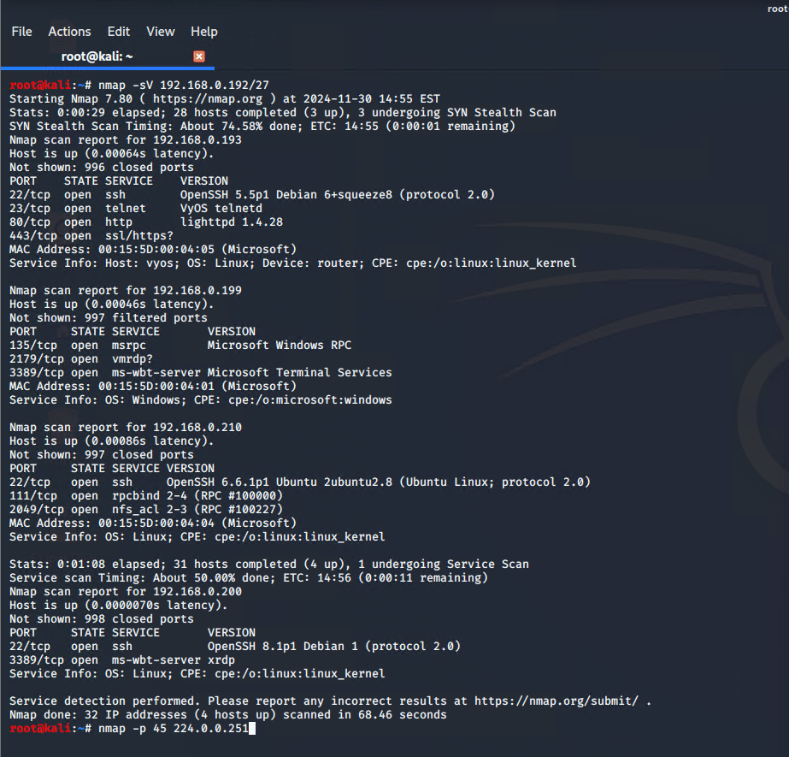

figure 3

In figure 4 it shows different ip addresses and different open ports but for now we will focus on .193 as seen from the figure 4 , port 23 is open and its telnet. Additionally, when simply google searching vyos we find it’s a router and simply following a guide from the official vyos website and simply using the credentials **vyos** for both the login and password we gain easy access to the router as seen from figure 5 below. To resolve this vulnerability the default credentials should be changed rather than the default credentials being used instead.

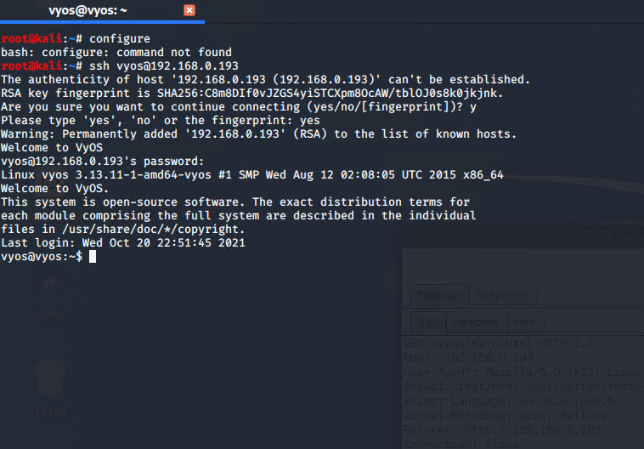

Figure 4

3.4 Accessing router 1:

Using the show interfaces command outputs additional networks as seen in figure 5

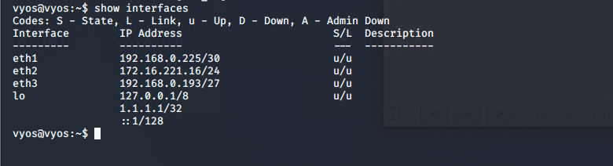

Figure 5- Additional Ip addresses connected.

We see eth 1 which suggests it’s another router due to its different subnet to eth3 is Router 1 and eth 2 might be another devise.

When using the guide and then enter show ip route of command we observer additional networks and where they are connected to as well.

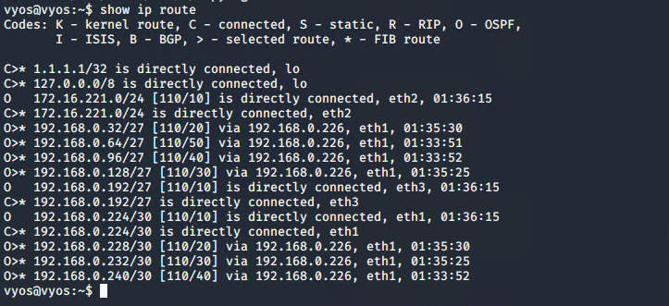

3.4.1-Investigating the Ip addresses from figure 6:

Eth 1 is another directly connected to Router 1 and the eth1 must be router 2 in this case and eth2 is unknown even conducting Nmap tests and only got what is shown in figure 6.

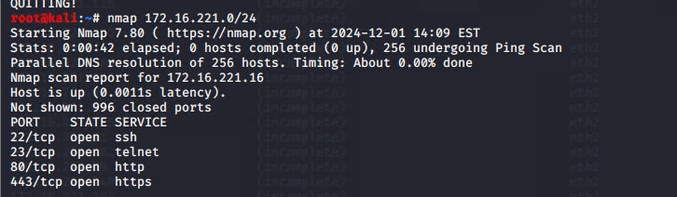

Figure 6

Eth3 is Router 1 shown in figure 5.

3.4.1-PC -192.168.0.210/27:

After using Nmap on 192.168.0.210/27 it is shown in figure 8 that there are ports 111 and 2049 (NFS) which contains potential sensitive data and its often used to share across a network and can be easily mounted from one pc to another and it means anyone who has access to these pc can access the NSF if they know how to mount it.

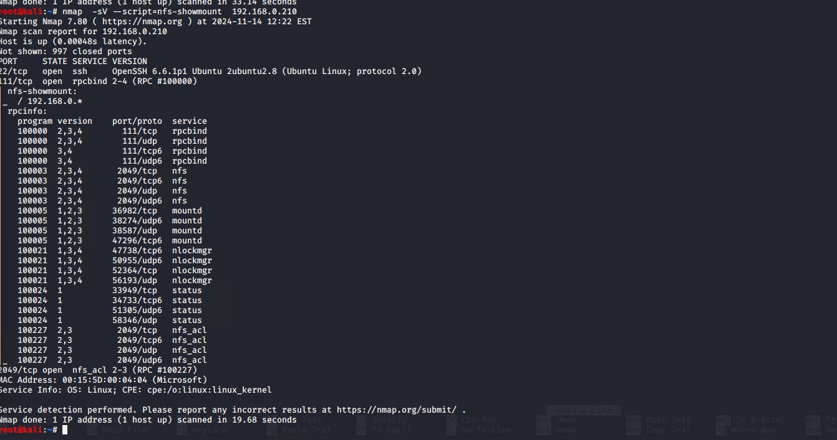

Figure 7

After starting the mount process, we get a collection of files now available on the 192.168.0.200 using cat to open each file.

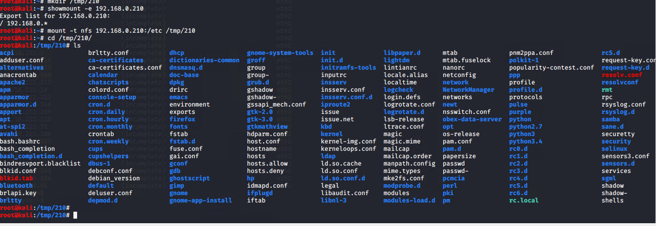

Figure 8

Looking at the different files using cat to read different files we see a hostname and when opened get xadmin-virtual-machine as in figure 9.

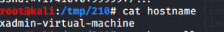

Figure 9

After exploring more files, we see passwd and passwd- which don’t contain anything useful. As seen in figure 10 and 12.

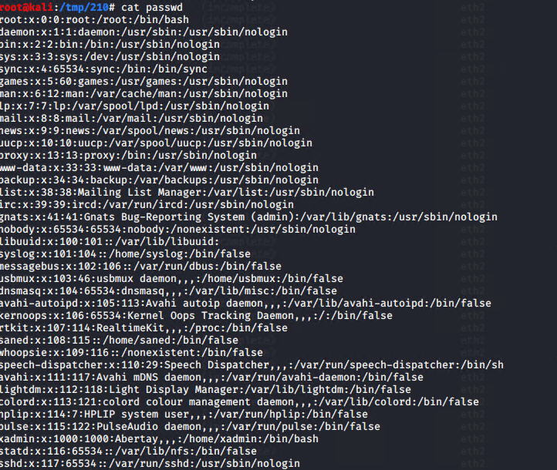

Figure 10

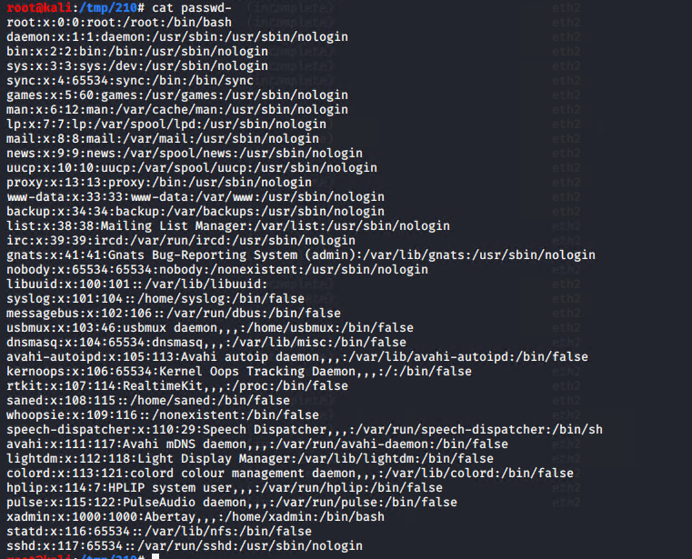

Figure 11

After opening each file, the shadow file contained hashes as shown in figure 13 below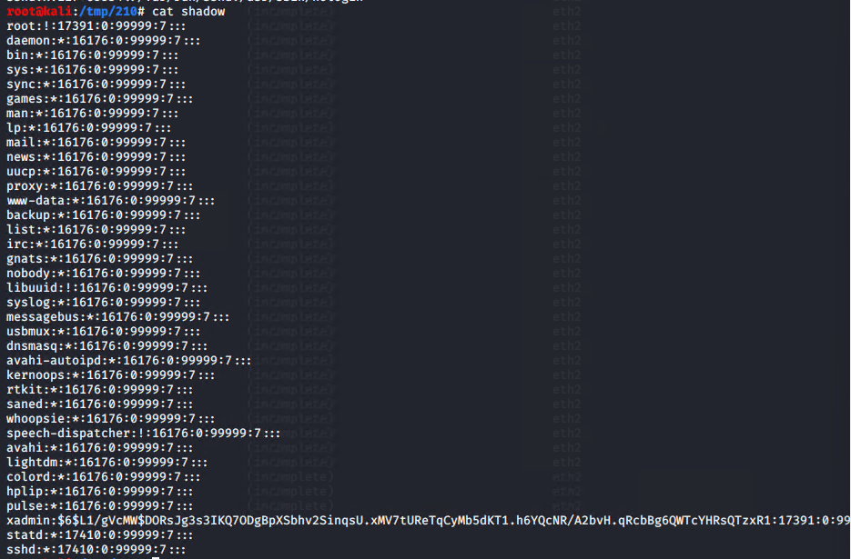.

Figure 12

Our main area of interest is the xadmin hash which has the password to access the machine and after doing some further analysis it’s a sha512 which are not to decrypt but attempting to use john and using different word list we see the out is **plums** in figure 13.

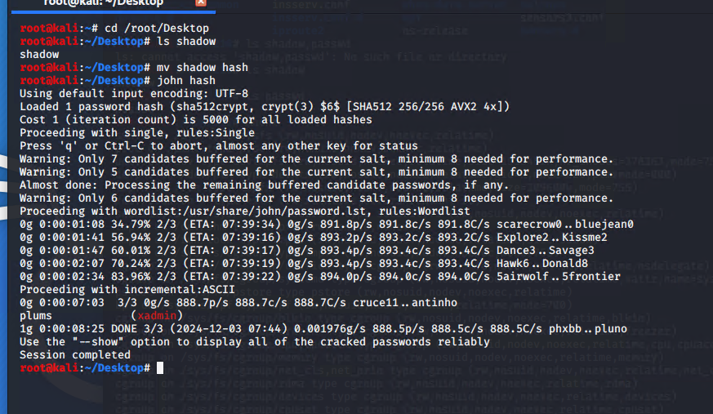

Figure 13-nfs file extraction.

Login to PC:

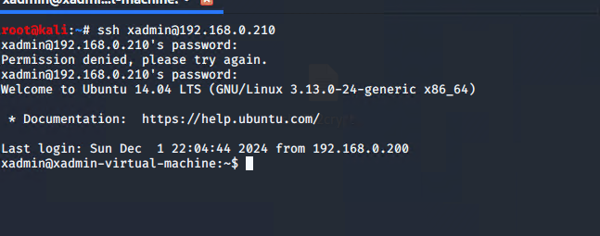

We now have access to 210 as seen in figure 14 and further analysing PC1 by doing an ipconfig to see if there any additional devises connected to it as see in figure 15.

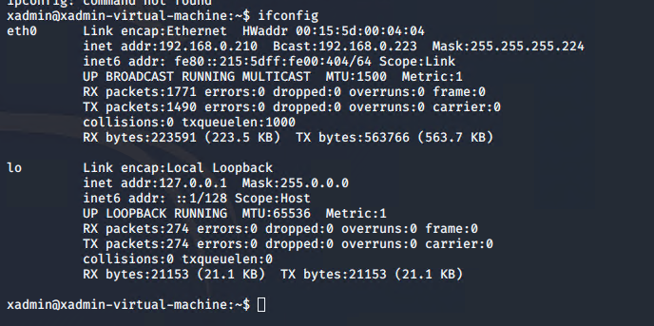

Figure 15

3.5-Router 2 – 192.168.0.226/30:

From the previous instigation of router, we saw eth1 might be another router so after conducting an aggressive nmap scan we see it’s a router and with ip 192.168.0.226 with a telnet port further showing its another router directly connected to router 1 which is 192.168.0.193 thanks to traceroute which is shown in figure 16.

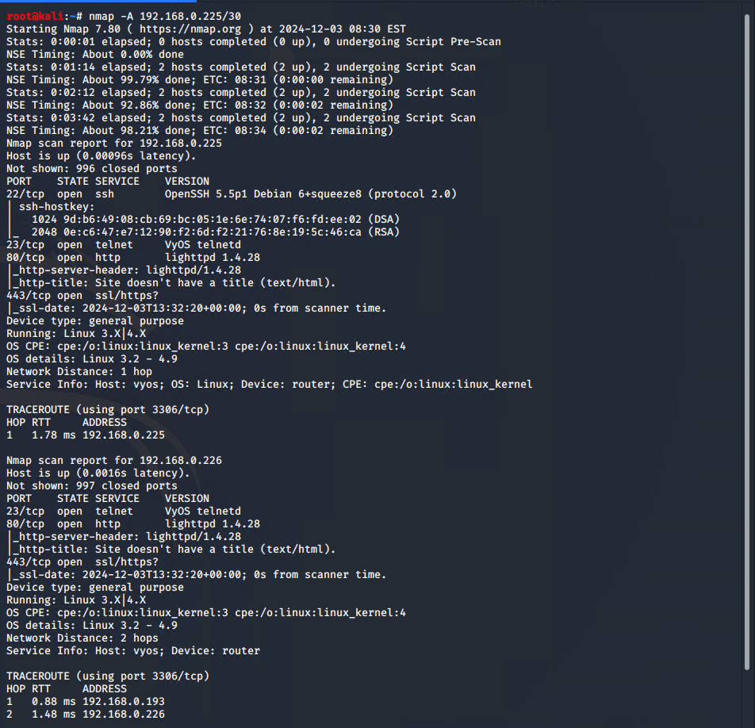

Figure 16

Doing the same steps taken from router 1and logging it was the same default credentials **vyos/vyos** which is a serious misconfiguration and using the ip route we see there are more devises present and doing show inter, we get the devises connected as shown Iin both figures 17 and 18.

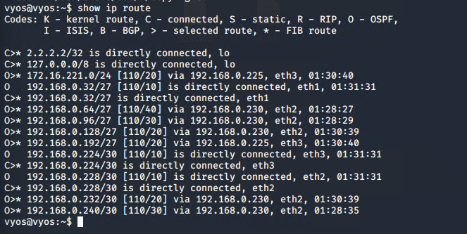

Figure 17

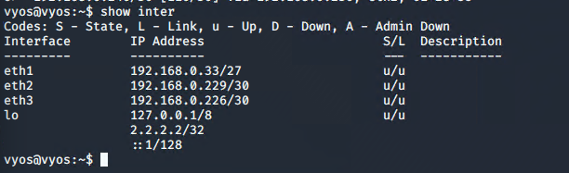

Figure 18

Eth1 is another computer with an address of 34/27 and eth 2 like router 1 with another rooter specifically router 3 and eth 3 is router 1 directly connected to it.

3.5.1-PC1 – 192.168.0.34/27:

After performing an aggressive nmap scan on 192.168.0.33/27 we see from figure 20 it’s another devise with NFS files with open ports 2049 and 111 with ip 192.168.0.34/27 indicating there is another devise in the network.

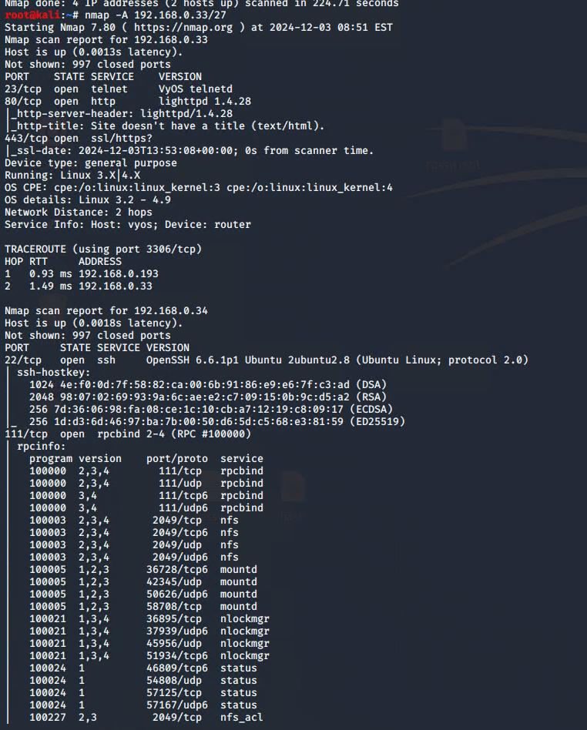

Figure 19- .34 discovery.

After discovering the devise an attempt was made to login to the devise using the same credentials of .210 **plums** which proved successful and access to .34 was made.

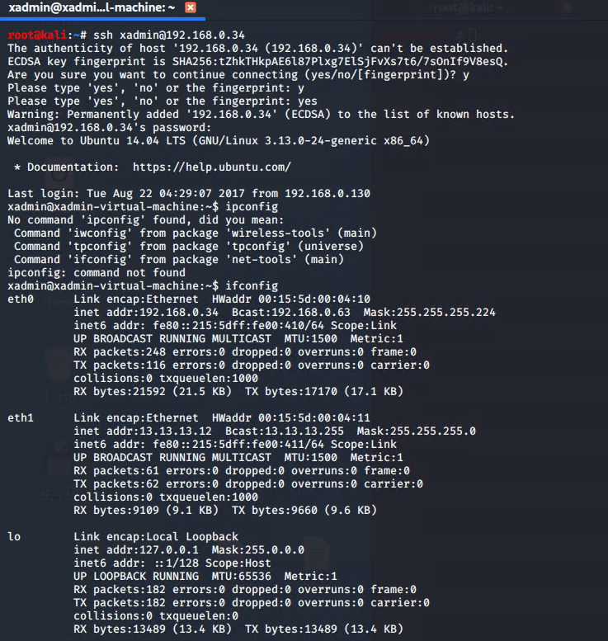

Figure 20 – shows an additional devise .12 which is 13.

To gain access to the new devise a pivoting point needs to be established from the kali machine to PC1. To accomplish this the ssh_config file would need to be changed to permit this and enable rooting and tunnelling as shown in figure 22 below.

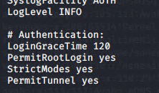

Figure 21 – PermitRootLogin changed from without-password to yes and PermitTunnel yes added to create the tunnel.

From figures 23 to 28 showcases the process and the results process undertaken to establish a pivoting connection.

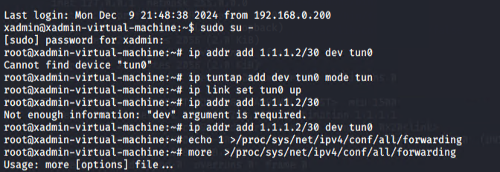

Figure 22- .34 root side of adding the route.

After adding the routes, a ping of both machines was done in to ensure the connection was working which in both figures 25 and 26 shows that each both pings work

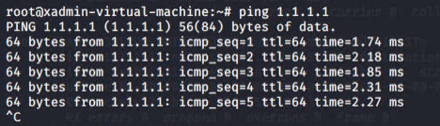

Figure 23 - ping 1.1.1.1.

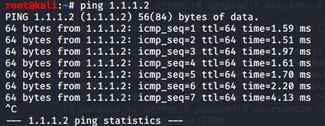

Figure 24 – ping 1.1.1.2.

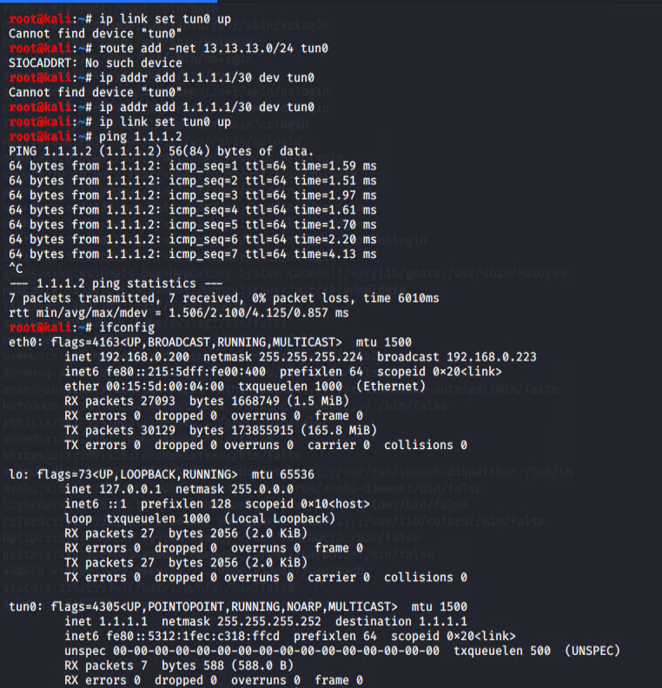

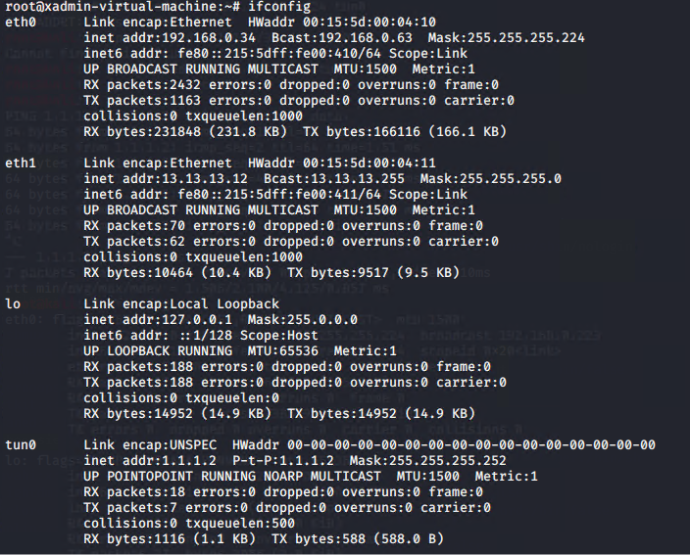Figure 25 – Adding route from kali.

Figure 26 – ifconfig routes.

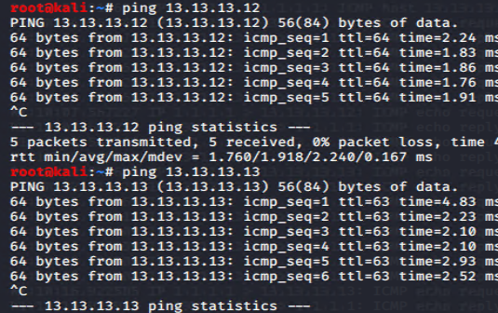

Figure 27 - Doing a direct ping to each ip address further shows there is a connection to the kali machine.

3.5.2-Exploiting PC2 - 13.13.13.13/24:

When a nmap was conducted against the machine it showed a 13.13.13.13 with an ssh port which will be important for later and 13.13.13.12 which is the bridge between 13.13.13.13 and 192.168.0.34.

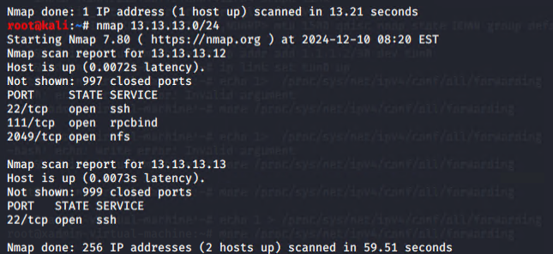

Figure 28

When trying to login to 13.13.13.13 using **plums**  it proved ineffective and Metasploit was needed to gain to access 13.13.13.13 for password cracking.

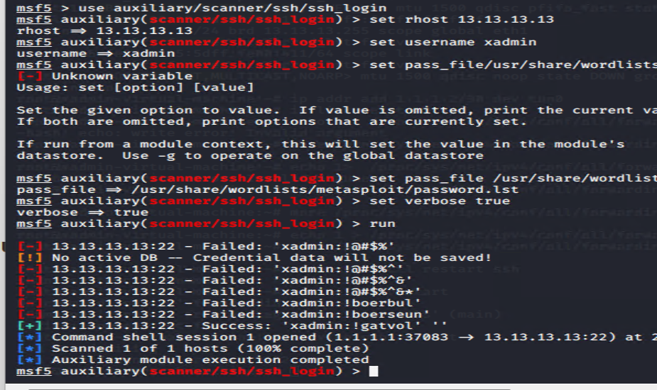



Figure 29 – process to gain the password for 13.13.13.13.

After running Metasploit using the ssh_login feature it proved successful and the password being **!gatvol**.

Using the password on .13 proved successful and after doing ifconfig as shown in figure 30 there are no other devises connected to it but .34.

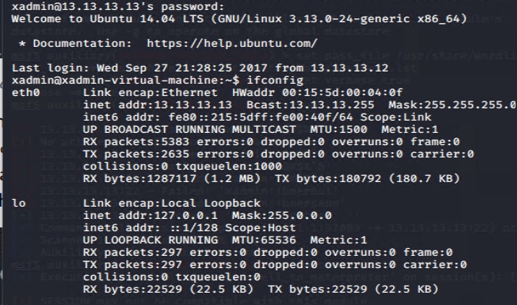

Figure 30 – output.

4 – Router 3 192.168.0.230/30:

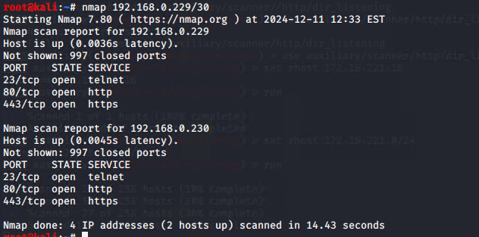

Figure 31 – nmap output.

After doing a nmap scan shown in figure 31 on 192.168.0.229/30 the ip address for router 3 is 192.168.0.230 based on logging in . After logging in using , the **vyos/vyos** default credentials which again is serious misconfiguration and then doing a show ip route it’s shown there are different devises connected to the router as illustrated in figure 32.

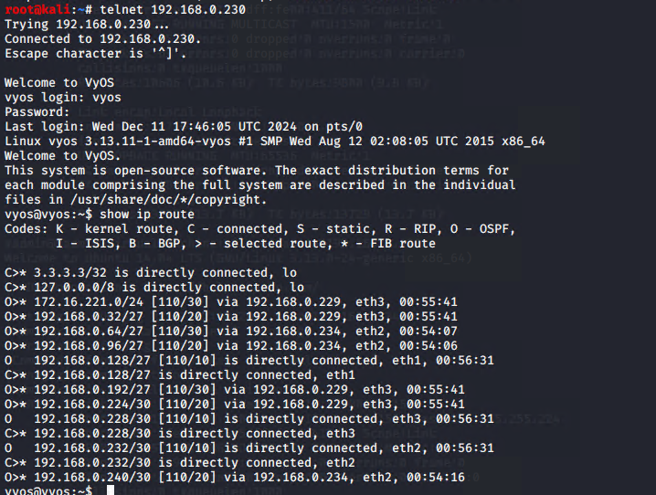

Figure 32 – different ip routes.

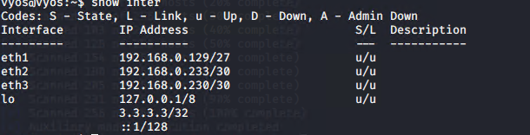

Figure 33 – different interfaces

After conducting different nmap scans on each interface its now known eth 1 is a pc connected to the network, eth2 is a firewall due to only one ip address being present when compared to the other scans which had more than one ip address present and eth3 is router 2 connected via the eth2 on router 2 side.

4.1-PC3 – 192.168.0.130/27:

When doing a nmap scan against PC3 it’s shown in the output that there is a nfs like .210 from earlier.

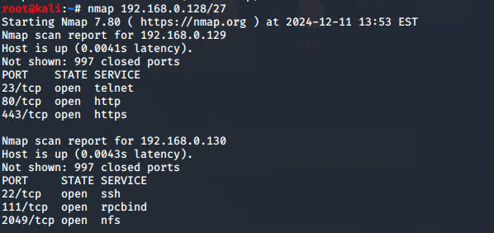

Figure 34

After trying to login to PC3 there was a permission denied with public key as illustrated in figure 35 . meaning a ssh key will be required possibly.

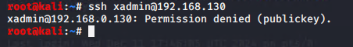

Figure 35

Since there is a port 2049 for NFS protocol it means the same steps conducted on .210 PC can be repeated in order extra useful information from PC3.

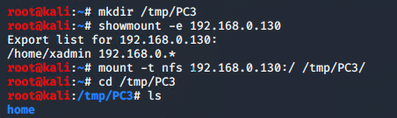

Figure 36

After creating the mounting point and after selecting the correct directory path it was now possible to view the authorised keys file as seen in figure 37



Figure 37 – change of directory to /tmp/PC3/home/xadmin/.ssh to access the file.

Further analysis showed within the key file there was presence a of a familiar number 34 as shown in figure 38

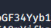

figure 38

Doing some further investigation, it showed that PC 2 was accessed by PC 3 at one point in the past after login into PC2 through PC3 which proved the speculations to be true and evidenced in figure 39.

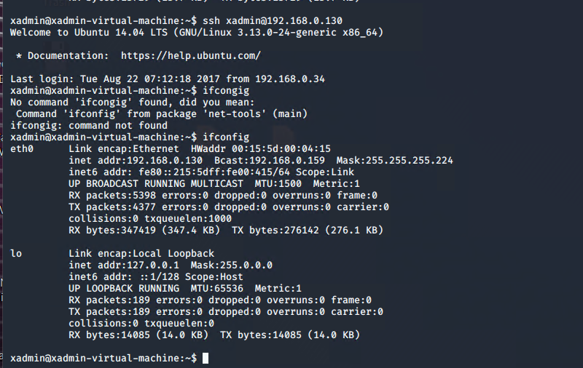

Figure 39 – last accessed by PC3 and doing a simple ifconfig command to see if there any other connected devises.

4.2-Web Server – 192.168.0.242/30:

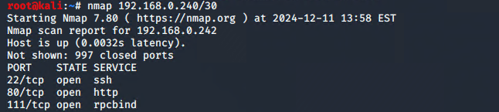

Figure 40

Doing a basic nmap on .240 as first shown in figure and being connected to eth2 it showed another ip address .242

After performing an aggressive nmap scan against this ip it was now obvious based port 80 having a header with CMP314 – Never Going To Give You Up and after entering the Ip address to Firefox it showed a website



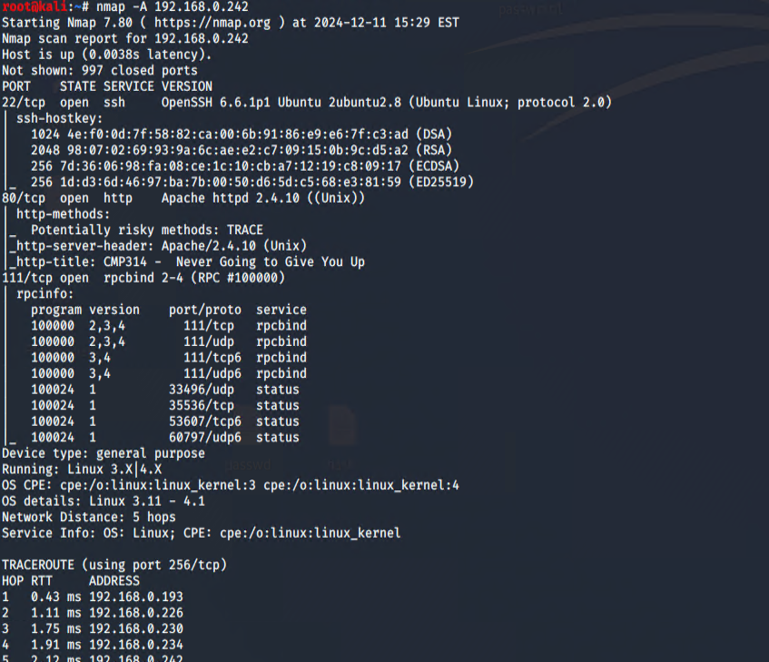



Figure 41– aggressive nmap output.

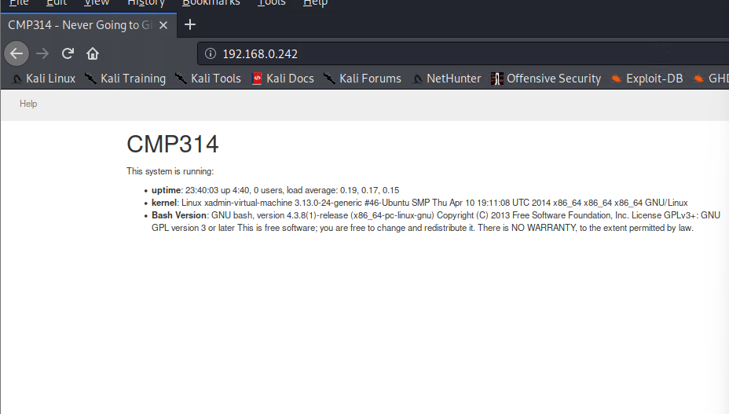

Figure 42 – website through firefox

4.2.1- Using Dirp against the web server:

Using dirb it showed a path /cgi-bin/ and when trying to access it the , it was forbidden. These means Metasploit will be needed to exploit the cgi-bin to gain further access to the firewall and to do so Shellshock will used to exploit the webserver since its Apache.

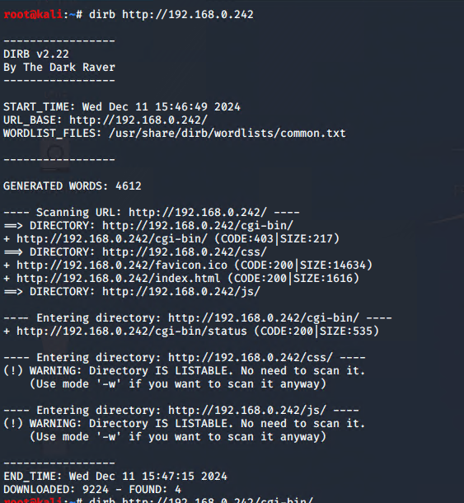



Figure 43 – Dirb output with an exploitable path.

4.2.2-Using Metasploit (Shellshock):

Using the dirb output we can use the shellshock which targets the http path to create a pivot point for port forward by targeting the /cgi-bin/status and set the rhost 192.168.0.242 to establish a session is to gain access to the firewall.

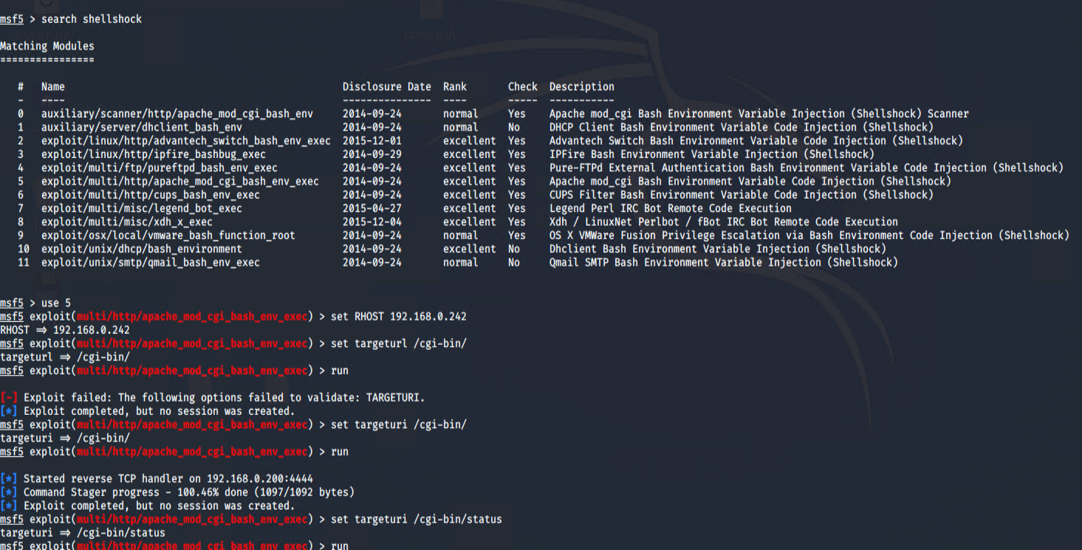

figure 44 – process to set up attack

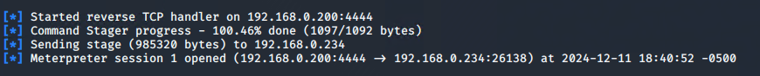

Figure 45 – successful session 1.

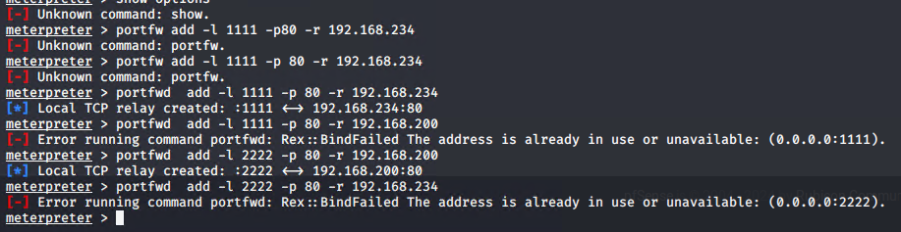

Through trial and error, a local tcp relay was made and after heading to localhost:1111 the firewall panel was accessible

4.3-Firewall:

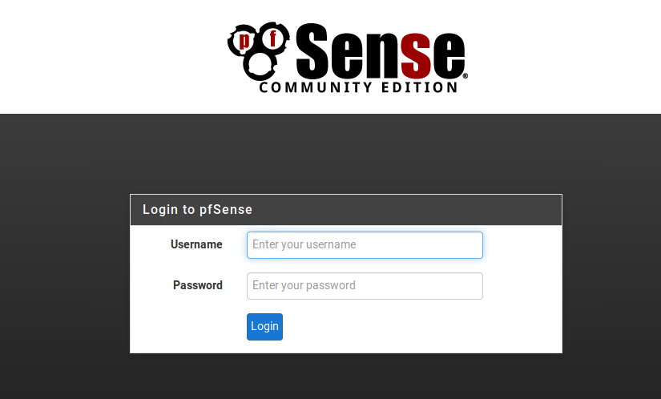

Figure 45 – Doing some googling the firewall uses the default credentials admin/pfsense.

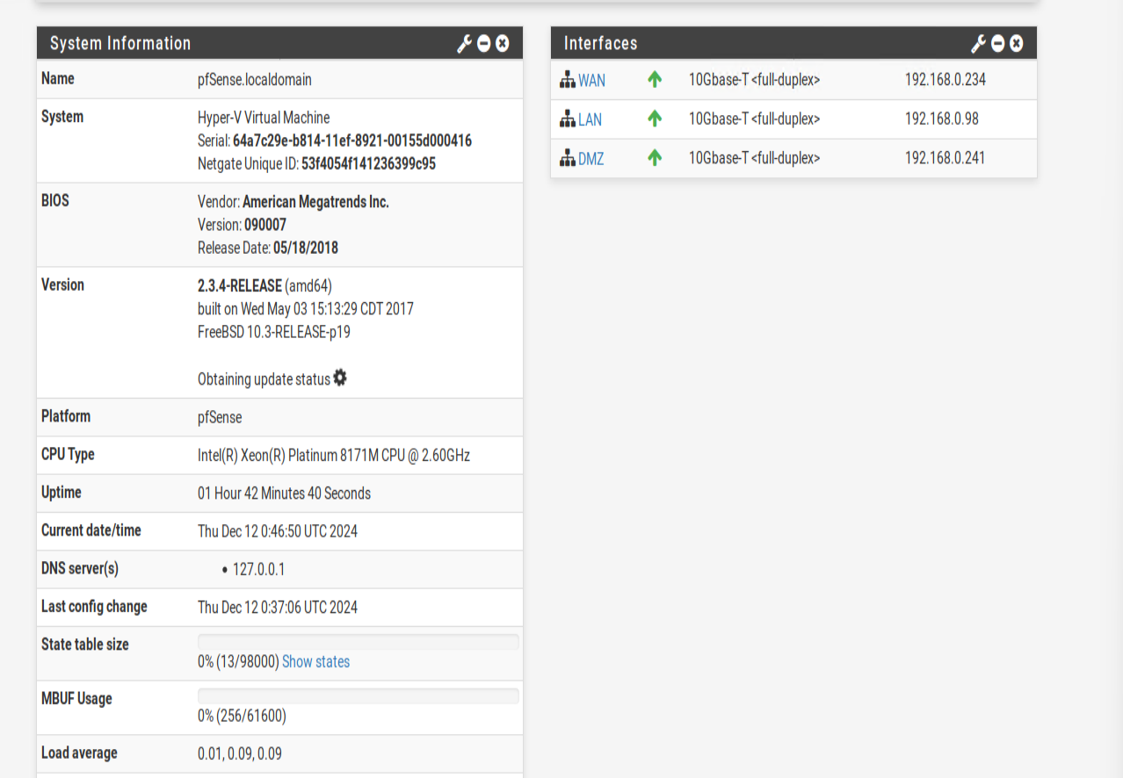

Figure 46

Based on this there are 3 different interfaces WAN is router 3 , LAN is router 4 based on attempt to login through telnet and DMZ is the web server. After further looking around the firewall a .66 was found and might be a devise connected to router 4.

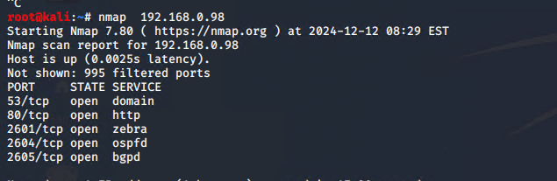

Figure 47 – Nmap of router 4

Testing had to be stopped due not being able to reestablish a session with the firewall even after some trouble shooting.

5-Security Weaknesses:

**5.1-Vyos Routers 1,2,3**

Throughout the testing phase of the network of each router that was accessed used the default credentials when first setting up a Vyos router , which all used **vyos** for user and **vyos** for password in order to login to the router itself. The best course of action would be to change the credentials for each router to a more complex username and password ideally storing these new credentials in a secure database in harsh format. The ability to also change who can access these routers as using telnet to connect to the routers is not encrypt and with the correct sniffing tools such as Wireshark.

Example of using Wireshark:

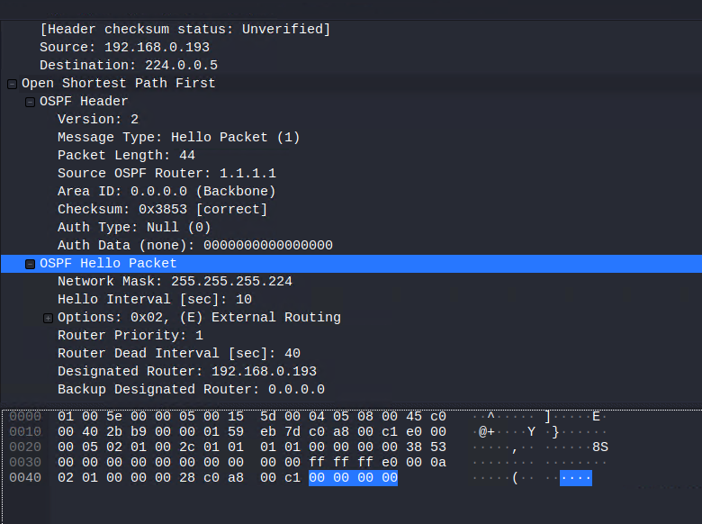

Figure 48 – Hello packet to find neighbouring devises.

The ip address 224.0.0.5 is a multicast address which helps other routers find each other and was also found in the firewall. These could be a possibly weakness as it could help an attacker map out a network as well.

Instead of using telnet ssh would be way more secure as encryption us standard for ssh ports.

**5.2-Basic PC Passwords:**

Although there were various steps undertaken to crack each pc password the passwords used such as **plums, !gatvo**l were very small in length a very basic for passwords. Each password was present within each wordlist meaning they could be found online very easily either being forum posts ect. The best course of action would be to scrap those existing passwords and increase the length of each new passwords and include special numerical values for each one for better security and at least a future attack would happen it would be a lot harder for the attacker to gain new passwords. It would be best to avoid any predictable or commonly used passwords as well for the future.

Another issue regarding with password was password reuse for two different pcs PC 1 and PC 2 which both used **plums** and would be best to consider the statement made above and each devise to have its own unique password rather that reusing them .

**5.3-NFS Sharing:**

When mounting different files from the nfs it was possible to view or specify different files from the remote devise meaning an attacker could gain valuable information and the best course of action would be to restrict all users on the network to only non-sensitive types of files to reduce the possibility of an attacker to gain any passwords or users as demonstrated from earlier in the report.

**5.4-Web Server:**

The web server used an out-of-date Apache 2.4.10 which came out in 2014 and since then different vulnerabilities have been discovered and would be the best interest for ACME to update this to the latest available version for better security.

The use of http is another issue with the webserver as it’s not secure because it can be prone to different kind of attacks or packet sniffing tool with the right implementation meaning ACME will need to use https which uses encryption and far less prone to attacks.

**5.5-Firewall:**

The firewall Pfsense used the default credentials which are easily accessible online to find which are admin/psfsesne and must be change to different credentials which are more complex.

**5.6-Network Design Critical Evaluation**

ACME’s network design implementation can be greatly improved by the number of misconfigurations with outdated software and very basic or repeated credentials which still used the default credentials like **vyos/vyos** for the router and firewall **admin/pfsense** from first use excluding the PC credentials which were **plums,!igatvol** which are very basic passwords for any given network used by different companies at any given scale. The telnet protocol is not secure and the use of http rather than using https. Using these protocols means easy exploitability for hackers to use different tools like Wireshark, Zap , Burp suite etc. Although each devise is connected separately meaning for future expansions for ACME’s network.

**5.7-Conclusion**

Overall, the ACME’s network requires many corrections within its network configuration and IT department by hiring a good team to deal with the issues within ACME’s network for better security and reduce the chances of attacks by any external sources from any given location or even internal ones sometimes. It would be best when the repairs undergo to isolate the network into a close private network until all corrections have been to the network and ACME finds another temporary network so their business can continue. I hope this report helps ACME greatly helps them in future to come.

References

**Accessing router 1:**

(Orion Documentation)<https://docs.orionvm.com/vyos/getting-started/> (Accessed 23 of November 2024) .

192.168.1.210/27 PC:

(GeeksforGeeks ) (<https://www.geeksforgeeks.org/cat-command-in-linux-with-examples/> ) (Accessed 23th of November 2024).

Additional Nmap commands:

Understanding nmap .arp-scan and netdiscover tools in linux (Author Jubril Edum May 9 ,2023)<https://jubriledun.hashnode.dev/understanding-nmap-arp-scan-and-netdiscover-tools-in-linux#heading-netdiscover>( Accessed 10th of December 2024).

Ssh Authentication:

(Author :Arron Patton) , (Jan 20,2020)<https://medium.com/stuff-ive-done/add-ssh-with-public-key-authentication-on-kali-ac0fc8f184bc> (Accessed 4st of December 2023).

Shellshock for Metasploit:

(Author: drd_.Jul26,2018-Aug 3 ,2018) <https://null-byte.wonderhowto.com/how-to/exploit-shellshock-web-server-using-metasploit-0186084/> (Accessed 11th of December 2024).

Sense firewall credentials:

(Netgate Docs)<https://docs.netgate.com/pfsense/en/latest/usermanager/defaults.html> (Accessed 12th of December 2024).

Appendixes

Appendix A-Subnet calculations

24/ Subnets

Subnet mask: 255.255.255.0

|  |  |  |  |
| --- | --- | --- | --- |
| ID | Network IP | Subnet Address Range | Broadcast Address |
| 0 | 13.13.13.0 | 13.13.13.1- 13.13.13.254 | 13.13.13.255 |
| 1 | 172.16.221.0 | 172.16.221.1- 172.16.221.254 | 172.16.221.255 |



254 usable hosts

Subnet Table /27



Network - 192.168.0.0

30 usable hosts

Subnet Mask: 255.255.255.224

|  |  |  |  |
| --- | --- | --- | --- |
| ID | Network IP | Subnet Address Range | Broadcast Address |
| 0 | 192.168.0.0 | 192.168.0.1 - 192.168.0.30 | 192.168.0.31 |
| 1 | 192.168.0.32 | 192.168.0.33 - 192.168.0.62 | 192.168.0.63 |
| 2 | 192.168.0.64 | 192.168.0.65 - 192.168.0.94 | 192.168.0.95 |
| 3 | 192.168.0.96 | 192.168.0.97 - 192.168.0.126 | 192.168.0.127 |
| 4 | 192.168.0.128 | 192.168.0.129 - 192.168.0.158 | 192.168.0.159 |
| 5 | 192.168.0.160 | 192.168.0.161 - 192.168.0.190 | 192.168.0.191 |
| 6 | 192.168.0.192 | 192.168.0.193 - 192.168.0.222 | 192.168.0.223 |
| 7 | 192.168.0.224 | 192.168.0.225 - 192.168.0.254 | 192.168.0.255 |

Based on this subnet table we now have a better understanding of the Network IP and in row 6 showcases the total usable Ip addresses.

30/Subnets

Only 2 available hosts per subnet



Subnet Mask : 255.255.255.252

|  |  |  |  |
| --- | --- | --- | --- |
| ID | Network IP | Subnet Address Range | Broadcast Address |
| 0 | 192.168.0.0 | 192.168.0.1 - 192.168.0.2 | 192.168.0.3 |
| 1 | 192.168.0.4 | 192.168.0.5- 192.168.0.6 | 192.168.0.7 |
| 2 | 192.168.0.8 | 192.168.0.9- 192.168.0.10 | 192.168.0.11 |
| 3 | 192.168.0.12 | 192.168.0.13 - 192.168.0.14 | 192.168.0.15 |
| 4 | 192.168.0.16 | 192.168.0.17 - 192.168.0.18 | 192.168.0.19 |
| 5 | 192.168.0.20 | 192.168.0.21- 192.168.0.22 | 192.168.0.23 |
| 6 | 192.168.0.24 | 192.168.0.25- 192.168.0.26 | 192.168.0.27 |
| 7 | 192.168.0.28 | 192.168.0.29 - 192.168.0.30 | 192.168.0.31 |
| 8 | 192.168.0.32 | 192.168.0.33- 192.168.0.34 | 192.168.0.35 |
| 9 | 192.168.0.36 | 192.168.0.37- 192.168.0.38 | 192.168.0.39 |
| 10 | 192.168.0.40 | 192.168.0.41- 192.168.0.42 | 192.168.0.43 |
| 11 | 192.168.0.44 | 192.168.0.45- 192.168.0.46 | 192.168.0.47 |
| 12 | 192.168.0.48 | 192.168.0.49- 192.168.0.50 | 192.168.0.51 |
| 13 | 192.168.0.52 | 192.168.0.53- 192.168.0.54 | 192.168.0.55 |
| 14 | 192.168.0.56 | 192.168.0.57- 192.168.0.58 | 192.168.0.59 |
| 15 | 192.168.0.60 | 192.168.0.61- 192.168.0.62 | 192.168.0.63 |
| 16 | 192.168.0.64 | 192.168.0.65- 192.168.0.66 | 192.168.0.67 |
| 17 | 192.168.0.68 | 192.168.0.69- 192.168.0.70 | 192.168.0.71 |
| 18 | 192.168.0.72 | 192.168.0.73- 192.168.0.74 | 192.168.0.75 |
| 19 | 192.168.0.76 | 192.168.0.77- 192.168.0.78 | 192.168.0.79 |
| 20 | 192.168.0.80 | 192.168.0.81- 192.168.0.82 | 192.168.0.83 |
| 21 | 192.168.0.84 | 192.168.0.85- 192.168.0.86 | 192.168.0.87 |
| 22 | 192.168.0.88 | 192.168.0.89- 192.168.0.90 | 192.168.0.91 |
| 23 | 192.168.0.92 | 192.168.0.93- 192.168.0.94 | 192.168.0.95 |
| 24 | 192.168.0.96 | 192.168.0.97- 192.168.0.98 | 192.168.0.99 |
| 25 | 192.168.0.100 | 192.168.0.101- 192.168.0.102 | 192.168.0.104 |
| 26 | 192.168.0.104 | 192.168.0.105- 192.168.0.106 | 192.168.0.107 |
| 27 | 192.168.0.108 | 192.168.0.109- 192.168.0.110 | 192.168.0.111 |
| 28 | 192.168.0.112 | 192.168.0.113- 192.168.0.114 | 192.168.0.115 |
| 29 | 192.168.0.116 | 192.168.0.117- 192.168.0.118 | 192.168.0.119 |
| 30 | 192.168.0.120 | 192.168.0.121- 192.168.0.122 | 192.168.0.123 |
| 31 | 192.168.0.124 | 192.168.0.125- 192.168.0.126 | 192.168.0.127 |
| 32 | 192.168.0.128 | 192.168.0.129- 192.168.0.130 | 192.168.0.131 |
| 33 | 192.168.0.132 | 192.168.0.133- 192.168.0.134 | 192.168.0.135 |
| 34 | 192.168.0.136 | 192.168.0.137- 192.168.0.138 | 192.168.0.139 |
| 35 | 192.168.0.140 | 192.168.0.141- 192.168.0.142 | 192.168.0.143 |
| 36 | 192.168.0.144 | 192.168.0.145- 192.168.0.146 | 192.168.0.147 |
| 37 | 192.168.0.148 | 192.168.0.149- 192.168.0.150 | 192.168.0.151 |
| 38 | 192.168.0.152 | 192.168.0.153- 192.168.0.154 | 192.168.0.155 |
| 39 | 192.168.0.156 | 192.168.0.157- 192.168.0.158 | 192.168.0.159 |
| 40 | 192.168.0.160 | 192.168.0.161- 192.168.0.162 | 192.168.0.163 |
| 41 | 192.168.0.164 | 192.168.0.165- 192.168.0.166 | 192.168.0.167 |
| 42 | 192.168.0.168 | 192.168.0.169- 192.168.0.170 | 192.168.0.171 |
| 43 | 192.168.0.172 | 192.168.0.173- 192.168.0.174 | 192.168.0.175 |
| 44 | 192.168.0.176 | 192.168.0.177- 192.168.0.178 | 192.168.0.179 |
| 45 | 192.168.0.180 | 192.168.0.181- 192.168.0.182 | 192.168.0.183 |
| 46 | 192.168.0.184 | 192.168.0.185- 192.168.0.186 | 192.168.0.187 |
| 47 | 192.168.0.188 | 192.168.0.189- 192.168.0.190 | 192.168.0.191 |
| 48 | 192.168.0.192 | 192.168.0.193- 192.168.0.194 | 192.168.0.195 |
| 49 | 192.168.0.196 | 192.168.0.197- 192.168.0.198 | 192.168.0.199 |
| 50 | 192.168.0.200 | 192.168.0.201- 192.168.0.202 | 192.168.0.203 |
| 51 | 192.168.0.204 | 192.168.0.205- 192.168.0.206 | 192.168.0.207 |
| 52 | 192.168.0.208 | 192.168.0.209- 192.168.0.210 | 192.168.0.211 |
| 53 | 192.168.0.212 | 192.168.0.214- 192.168.0.215 | 192.168.0.216 |
| 54 | 192.168.0.216 | 192.168.0.217- 192.168.0.218 | 192.168.0.219 |
| 55 | 192.168.0.220 | 192.168.0.221- 192.168.0.222 | 192.168.0.223 |
| 56 | 192.168.0.224 | 192.168.0.225- 192.168.0.226 | 192.168.0.227 |
| 57 | 192.168.0.228 | 192.168.0.229- 192.168.0.230 | 192.168.0.231 |
| 58 | 192.168.0.232 | 192.168.0.233- 192.168.0.234 | 192.168.0.235 |
| 59 | 192.168.0.236 | 192.168.0.237- 192.168.0.238 | 192.168.0.239 |
| 60 | 192.168.0.240 | 192.168.0.241- 192.168.0.2342 | 192.168.0.243 |
| 61 | 192.168.0.244 | 192.168.0.245- 192.168.0.246 | 192.168.0.247 |
| 62 | 192.168.0.248 | 192.168.0.249- 192.168.0.250 | 192.168.0.251 |
| 63 | 192.168.0.252 | 192.168.0.253- 192.168.0.254 | 192.168.0.255 |